1

MELS.

Economic aspect
2

Leopold II [King of the Belgians] then began to exploit [the colony’s resources]: in return for royalties,1 he granted companies monopolies2 on the harvesting of rubber and ivory [from the Congo, in Africa]. These companies took unfair advantage of the situation. They subjected the Blacks to forced labour, made them pay taxes in ivory, inflicted physical punishment and brutally crushed all resistance. . . .
1. royalty: a kind of tax
2. monopoly: special privilege
Jean Lefevre and Jean Georges, Les temps contemporains, vol. 1: 1815-1945 (Brussels: Casterman, 1973), 268. [Translation]

3

Colonization brought . . . changes . . . to the continent’s layout, which became covered with ports, railways, modern agricultural plantations . . . .
Christian Laville, From Yesterday to Tomorrow, Secondary Cycle One, (Montréal: Graficor, 2008) Student Textbook B, 190.

4

The South African mines were organized just like prisons. As long as the miners were under contract, they could neither leave, nor communicate with the exterior. The wages were reasonable, but the Whites were paid ten times more than the Blacks.
Sébastien Brodeur-Girard et al., L’Occident en 12 événements: De l’industrialisation à la reconnaissance des libertés et des droits civils, 1er cycle du secondaire (Laval: Grand Duc, 2006), Student Textbook 2B, 328. [Translation]

Cultural aspect
5
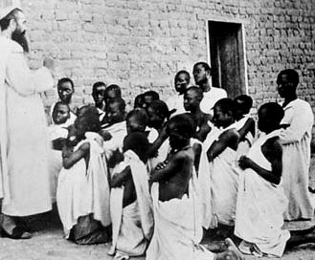
A missionary at work in Africa in the early 20th century

Bernard Klein and Gérard Hugonie, Histoire Géographie 4e (Paris: Larousse-Bordas, 1998), 159.

6

Among the aspects . . . of the European colonization of Africa, the development of infrastructure . . . the introduction of modern medicine and the education of the elites are frequently mentioned. . . . The colonizers also tried to assimilate the African cultures by imposing their language, religion and calendar on them, dismissing traditional medicine and having them adopt [European] clothing . . . .
France Lord and Jean Léger, Histoire en action, 1er cycle du secondaire (Mont-Royal: Modulo, 2006), Student Textbook 2, 233. [Translation]

7

. . . the language of the mother country became the language of administration and communications. To understand a legal judgment or a law adopted by the European authorities, the Africans had to know the language of their colonizer.

. . . In the colonial schools, the students were introduced to European culture and history, which were presented as superior to their own.
Line Lamarre, ed., Réalité: Histoire et éducation à la citoyenneté, 1er cycle du secondaire (Saint-Laurent: ERPI, 2006), Student Textbook 2B, 256. [Translation]

Political aspect
8

Despite the rapid invasion of Africa, colonial expansion did not proceed without resistance. On the contrary, the colonial powers faced numerous local rebellions. But while Africans did not remain passive in the face of colonial imperialism, they nevertheless had to give way to the powerful European armies.
Christian Laville, From Yesterday to Tomorrow, Secondary Cycle One (Montréal: Graficor, 2008), Student Textbook B, 193.
9

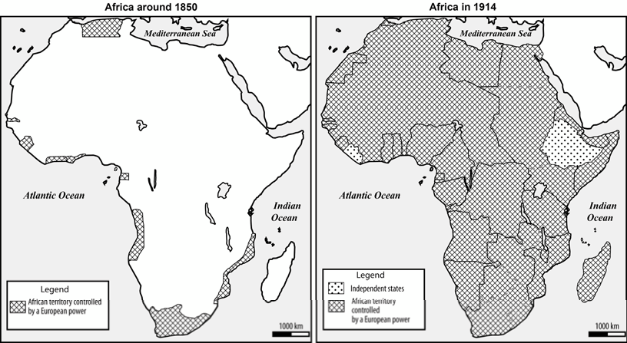
Colonial expansion in Africa

MELS.

10

Even when it leaves . . . the traditional political chiefs in place . . . the colonizing power takes over the reality of power, without which it would lack a solid base for domination. The colonized [population] is thus excluded from the centres of decision making . . . .
George Langlois et al., Histoire du 20e siècle (Laval: Beauchemin, 1994), 360. [Translation]

11
The Herero fighting the
Germans in Southwest Africa
early in the 20th century

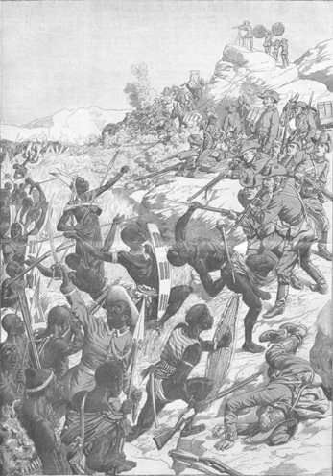
“Bitter fighting in Southwest Africa,” in Le Petit Journal, Supplément du dimanche, (Paris), February 21, 1904, 64.

